
Relationships can’t happen without communication, and our God is relational. He knows us and wants to be known by us. He is the God who speaks. Throughout His story, we see our Father talking to His kids. Whether in an audible voice or a gentle whisper, or through the godly advice of others, God speaks. And His words are always worth listening to. As we explore in this series the Old Testament stories of people who listened (and didn’t listen) to God’s voice, may you and your kids tune your ears to the kind voice of our loving Father.
Series Overview
Bible Story | Bible Passage | Wonder Truth
God Calls Out to Samuel | 1 Samuel 3 | God Speaks
Samuel Anoints David as King | 1 Samuel 16 | God Looks at the Heart
The Kingdom Divides | 1 Kings 12 | God Wants Us to Follow Godly Advice  *We Can Follow God
God Whispers to Elijah | 1 Kings 19 | God Can Speak to Us in Unexpected Ways  *God Can Speak to Us
*Early Childhood

WORD OF WONDER
Come near to God, and he will come near to you. —James 4:8a


FAMILY WONDER QUESTIONS
- Share about a person you like to talk with. Why?
- Have you felt or heard God speaking to you? When?
- What do you think God sees when He looks at your heart?
Family Spiritual Practices
- Look at my Heart: In 1 Samuel 16, God chose David as King because God saw his heart. In Psalm 139:23–24, David writes that God knows what’s in the heart and asks God to examine His heart. Draw a picture of a heart and then pray together and ask God to examine your hearts. Read Psalm 139 and pray the words of the verse.
- The Examen: In 1 Kings 19, Elijah hears God speaking in an unexpected way: a still, small whisper. God speaks to us too! The Examen is a practice of noticing where God is at work or speaking. Do it as a family at the end of the day: start by being still before God. Think about your day and consider the ways God may have been moving or speaking. Ask each person how God was present today. Then pray together and thank God as you listen for Him.
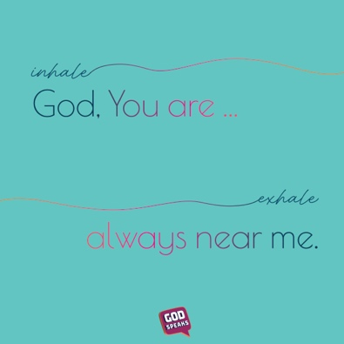
BREATH PRAYER
 |  | 
Scan for At-Home Bible Story Video YouTube® |  | Scan for Spotify™ playlist
A breath prayer is a word or phrase to repeat in a single breath with one part on the inhale and the other part on the exhale. Breath prayers help us focus on God and His presence with us. Try this together as a family.

Inhale: God, You are …
Exhale: always near me.

