|  |  |  |
| --- | --- | --- |
|  | | |
| What does it mean to worship God? While worshiping through music may be the first thing that comes to mind, we’ll learn through this series that at its core, worship is an overflow of love and a response to who God is and what He has done. Let’s worship together! | | |
| Series Overview | | |
| **Bible Story** | **Bible Passage** | **Wonder Truth** |
| The Shema | Deuteronomy 6 | God Wants Us to Worship with Our Whole Selves  God Wants Us to Worship with Our Whole Lives* |
| David  Worships God | 2 Samuel 6 | God Is Honored When We Worship with Our Whole Hearts  God Loves When We Worship with Our Whole Hearts* |
| A Psalm of Praise | Psalm 145 | God Is Worthy of Worship  God Deserves Worship* |
| Jehoshaphat and the Singing Army | 2 Chronicles 20 | God Is with Us When We Worship |
| Feast of Tabernacles | Leviticus 23 | God Invites Us to Worship and Celebrate  We Can Worship and Celebrate God* |
| *Early Childhood | | |
| WORD OF WONDER | | |
| *Worship the LORD with gladness. Come to him with songs of joy.*  *—Psalm 100:2* | | |
|  | | |
|  | | |

|  |
| --- |
|  |
| FAMILY WONDER QUESTIONS |
| 1. What does it mean to love God with your heart, soul, and strength? 2. What is worship? *(Giving honor to someone or something and putting them first.)* 3. What is your favorite way to worship God? Why? |
|  |
| Family Spiritual Practices |
| * **Celebration:** “Every good and perfect gift is from God” (James 1:17)! As a family, choose an activity you all delight in, such as preparing and sharing a favorite meal, hiking at a nearby park, or hosting a family dance party. Engage in it together as you celebrate the Gift-giver! * **A New Song:** “Sing a new song to him … shout with joy” (Psalm 33:3). What amazes you most about God? What do you love about Him? Tell Him in an original song or poem. Write one as a family, or invite family members to write and share their own. Then put the words to music or shout them out to God with joy! |

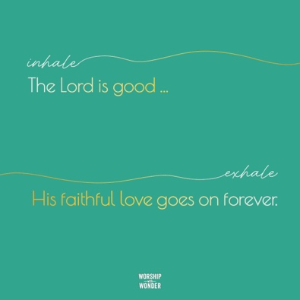**BREATH PRAYER**

|  |  |  |
| --- | --- | --- |
|  |  |  |
| Scan for At-Home Bible Story Video YouTube® | Scan for Spotify™ playlist |

|  |  |  |
| --- | --- | --- |
|  |  |  |
|  |  |

A *breath prayer* is a word or phrase to repeat in a single breath with one part on the inhale and the other part on the exhale. Breath prayers help us focus on God and His presence with us. Try this together as a family.  
  
Inhale: The Lord is good …  
Exhale: His faithful love goes on forever.